

**HR_SBD_PROG-DEV**potential candidates testing

|  |  |
| --- | --- |
| **Created:** | Zoran Tall **©** CADENAS GmbH |
| **Date:** | 02.08.2019. |
|  |  |
|  |  |
|  |  |

Content

1. Change history 3

2. Task 4

3. Details 5

4. Final thought 7

# 1. Change history

|  |  |  |
| --- | --- | --- |
| **Editor** | **Description** | **Date** |
| Zoran Tall, CADENAS | created | 02.08.2019 |
|  |  |  |
|  |  |  |
|  |  |  |

# 2. Task

Create single page web application for buying tickets. Something similar to CineStar application.

Requairements are:

* Section where user can select from available shows
* Section where user can choose type and amount of tickets
* Section where user can choose seats available
* Final section for billing (mockup only)

There is no need for database, data available for presentation can be implemented in project as You see fit (JSON, text… )

It should be graphically pleasing but no need to complicate with elaborate graphic schemes (form and function).

Responsive design is desirable (if needed Bootstrap can be used).

Technologies used are JavaScript, HTML, CSS and anything that you think it is necessary (see next section).

Libraries can be used (E.g. JQuery) but try to limit them to minimum and avoid using javacsript frameworks as the purpose of this testing as to evaluate knowledge of basic frontend development/design.

# 3. Details

These are only examples images. Design and color schemes are to Your liking. Make it user friendly and esthetically pleasing.

On first section user can choose what show to watch and day/time to watch it. Image is just example.

Important parts are weekly schedule of shows and show details.

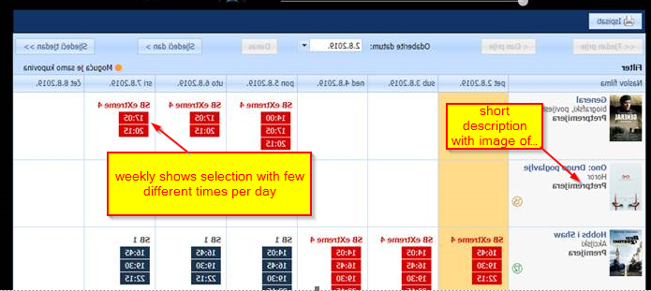

On section where seats are chosen there are two section. First is for ticket buying and second is for seats selection.

Important things are:

* When user choose amount of tickets price will change
* When user choose seats application algorithm will suggest seating and will not allow already taken seats to be selected. (for more details check out Cinestar web application)

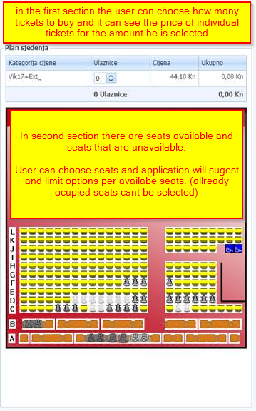

On billing section, we need next information:

* Number of tickets
* Seating positions
* Selected shows
* Date and time of show
* Total price

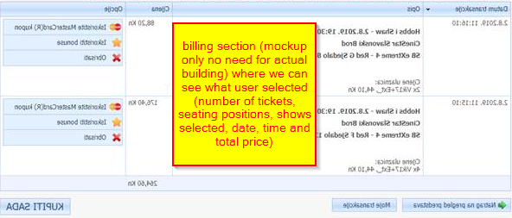

# 4. Final thought

Important thig is that this is testing of coding / design skills no need to spend to much time on graphic.

Images, descriptions and test used are not that important. General feel and usability is more important.

It is mockup design rather that real application but it needs to be functional it terms of requirements of this testing.

Any question that you might have can be asked on [z.tall@cadenas.de](mailto:z.tall@cadenas.de)

Time for this project is two weeks follow by presentation.